This document contains four BS designs. They are all designed for a max 45 deg deflection angle @ 1 kN tension, but the upper tension limit varies as follows:

* Tmax = 25 kN; Vmin = 1 deg
* Tmax = 20 kN; Vmin = 1 deg
* Tmax = 15 kN; Vmin = 1 deg
* Tmax = 10 kN; Vmin = 1 deg

Graphically it looks like this:

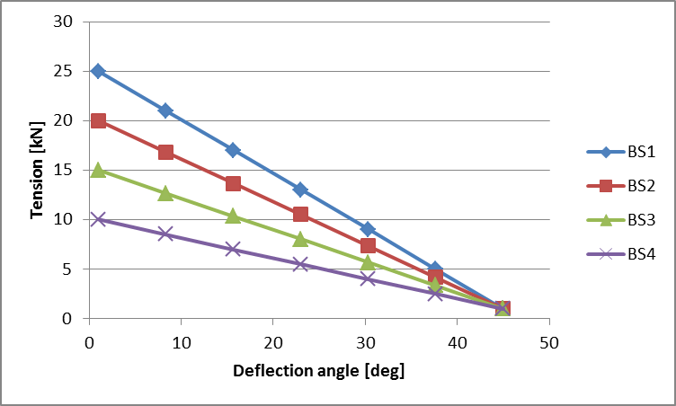

In the following I have added results for each BS. I have plotted the performance together with the umbilical’s capacity. The stress-strain curve is for PU Shore 95 A (curve attached in Excel file).

BS size summary (all in [mm]):

|  |  |  |  |  |
| --- | --- | --- | --- | --- |
|  | **BS1** | **BS2** | **BS3** | **BS4** |
| «Stiff» root length | 300 | 300 | 300 | 300 |
| Conical length | 1800 | 1500 | 1200 | 900 |
| Tip length | 100 | 100 | 100 | 100 |
| **Total length** | **2200** | **1900** | **1600** | **1300** |
| **OD root** | **323** | **289** | **246** | **215** |
| OD tip | 100 | 100 | 100 | 100 |
| ID | 70 | 70 | 70 | 70 |

Performance:

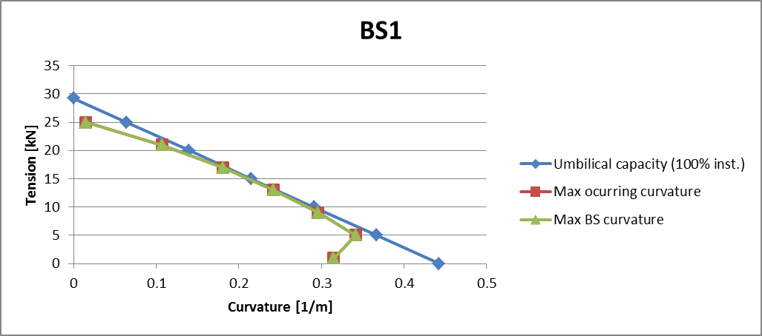

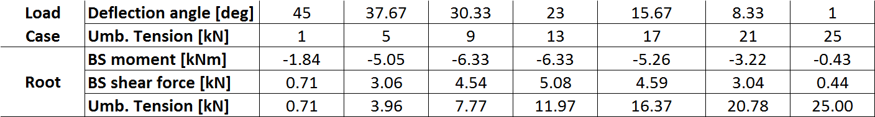

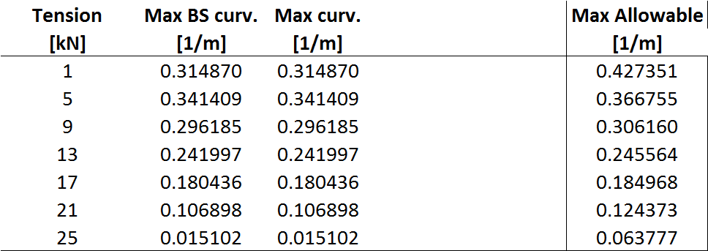

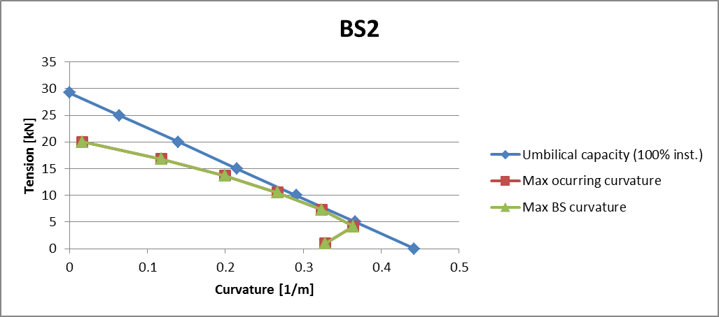

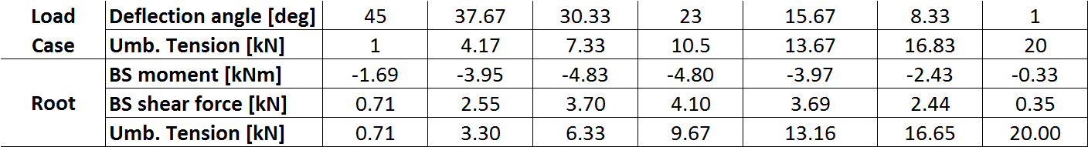

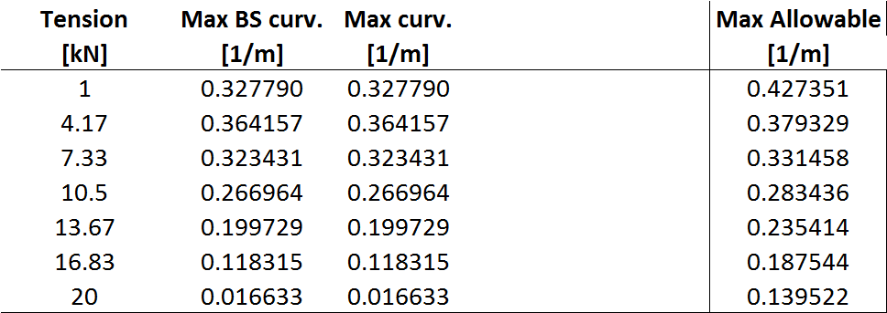

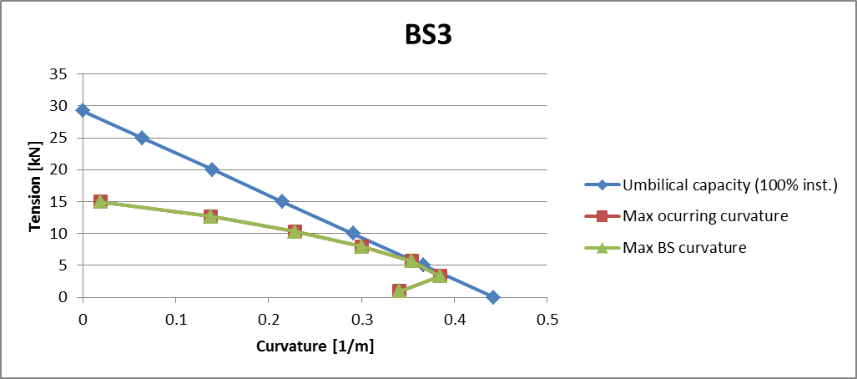

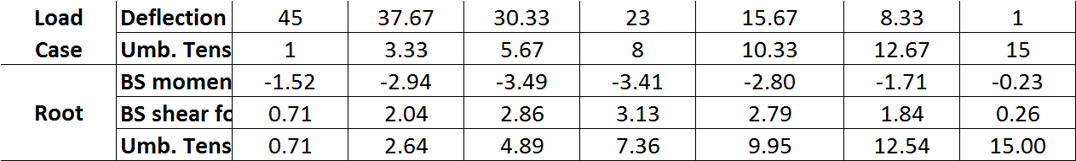

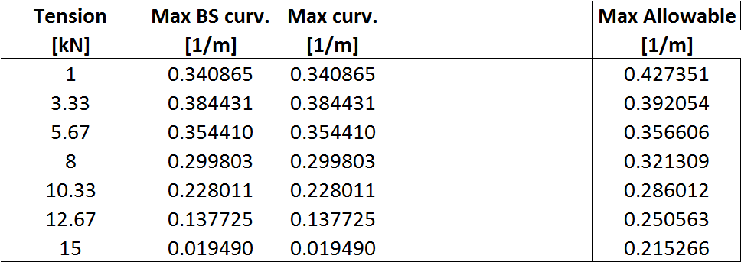

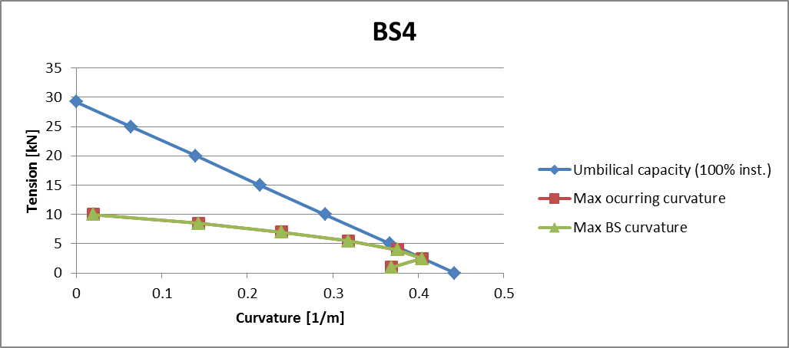

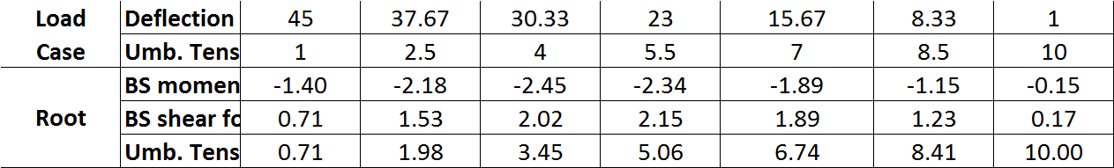

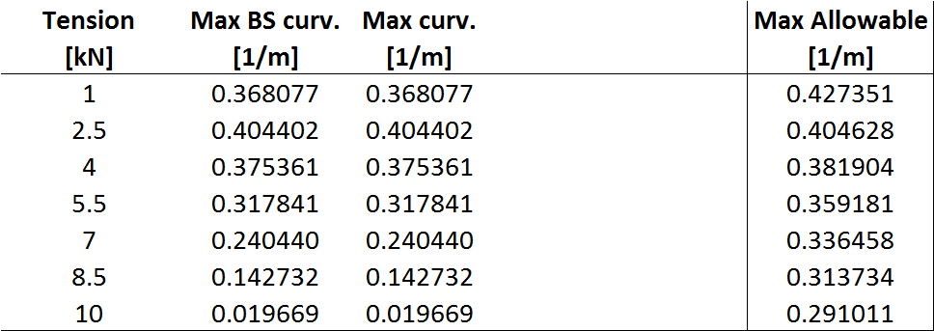

Knut I. Ekeberg